
One-Stop Repair Shops

The Sanctuary Fund & New Day Foundation – Give2Asia
September 2007 – February 2009
Final Project Report

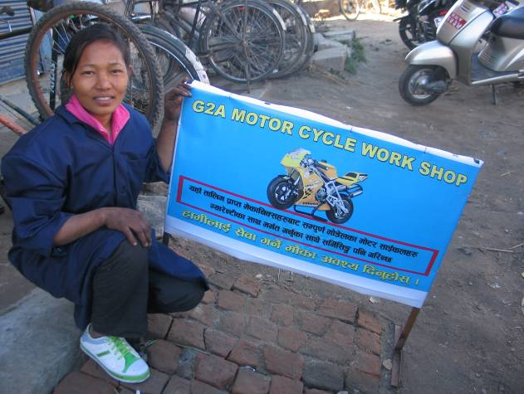
The “One-Stop Repair Shop” project in Nepal was initially funded by the Sanctuary Fund at Give2Asia with $18,750, and supported the establishment of four workshops for the gainful and sustainable employment of young women trained in non-traditional vocations. The project provided viable sources of income for vulnerable young women from remote and/or conflict-affected areas of Nepal who were considered at risk of being trafficked. By establishing the female-run workshops, women trainees in vocations such as electrical and motorcycle repair and maintenance not only became self-employed, running and managing their own workshops, but also significantly reduced their risk of being trafficked or having to work in an exploitative situation. Further, they have set an example of what women from even the most difficult backgrounds and low education levels in Nepal can do if provided with skills and opportunities.

Initially, after receiving the grant from the Sanctuary Fund, The Asia Foundation (TAF) signed a tripartite agreement with the Nepal Rugmark Foundation (NRF) and the Underprivileged Children’s Educational Program (UCEP) Nepal to establish four fully-equipped workshops for six women trainees. The project was implemented by NRF and UCEP with oversight by TAF, as Foundation staff had worked closely with both groups over the previous several years in providing training in non-traditional vocations to the young women through the “Gainful Employment Opportunities Program for Young Women at Risk of Trafficking and Trafficking Survivors (GEO),” a project funded by USAID.

By August 2008, two electrical shops and two motorcycle workshops were fully operational, and the young women running these shops had started earning a profitable income from their businesses. After observing the success of the one-stop shop model in October 2008, another donor to Give2Asia, the New Day Foundation, decided to provide an additional $9,900 to furnish the four existing workshops with additional equipment and tools, and establish a third motorcycle workshop to provide employment for two more women from the GEO project. This fifth shop is also now operational six months later, and this report serves as the final project report for both supporters of the One-Stop Repair Shops in Nepal.

Project Accomplishments:

The primary accomplishment of this project was the empowerment of vulnerable young women in Nepal, who became self-employed with sustainable incomes through non-traditional jobs, while breaking barriers in traditionally male-dominated fields. Other accomplishments of the project include:

- Provision of equipment and technical support to establish two electrical shops and three motorcycle shops overall in the Kathmandu Valley for eight women trainees.

- Within one year of their establishment, transfer of ownership of the shops to the project beneficiaries and officially register them with the government.

- Provision of living expenses for the first 3-6 months of the project, until the women could earn a living on their own from the shops.

- Provision of one senior technician (supervisor) for the first three months of the shops’ establishment to oversee the workshops and guide the women in their work.

- Provision of refresher training, transition support, and counseling, to the women throughout the life of the project, and maintaining those relationships going forward to ensure a support system for them.

- With additional funding from the New Day Foundation, provision of additional tools and equipment for the four existing workshops.

- With additional funding from the New Day Foundation, establishment of a fifth workshop in Kathmandu (third motorcycle shop) and, within three months of establishment, transferring its ownership to the two women running the shop.

PROJECT ACTIVITIES

Establishment of the initial four workshops.
Within the first five months of the project’s launch, Foundation staff worked with NRF and UCEP to establish two motorcycle repair workshops and the first of two electric shops.

The first motorcycle repair shop was established in December 2007, on a relatively busy road in Sano Thimi, Bhaktapur, one of the three cities in Kathmandu Valley. Three young women were placed in that shop, but unfortunately one of them dropped out of the project for family reasons. The two remaining women are doing well in this location and have already doubled their income from only six months ago (more details below). A second motorcycle shop was established in Suryabinayak Chowk, Bhaktapur for two additional young women. However, because it was in a very busy part of Bhaktapur, it faced a great deal of competition and had a hard time generating income. This shop was subsequently moved to a more suburban location in Imadol, where it is the only motorcycle shop around and is now very successful.

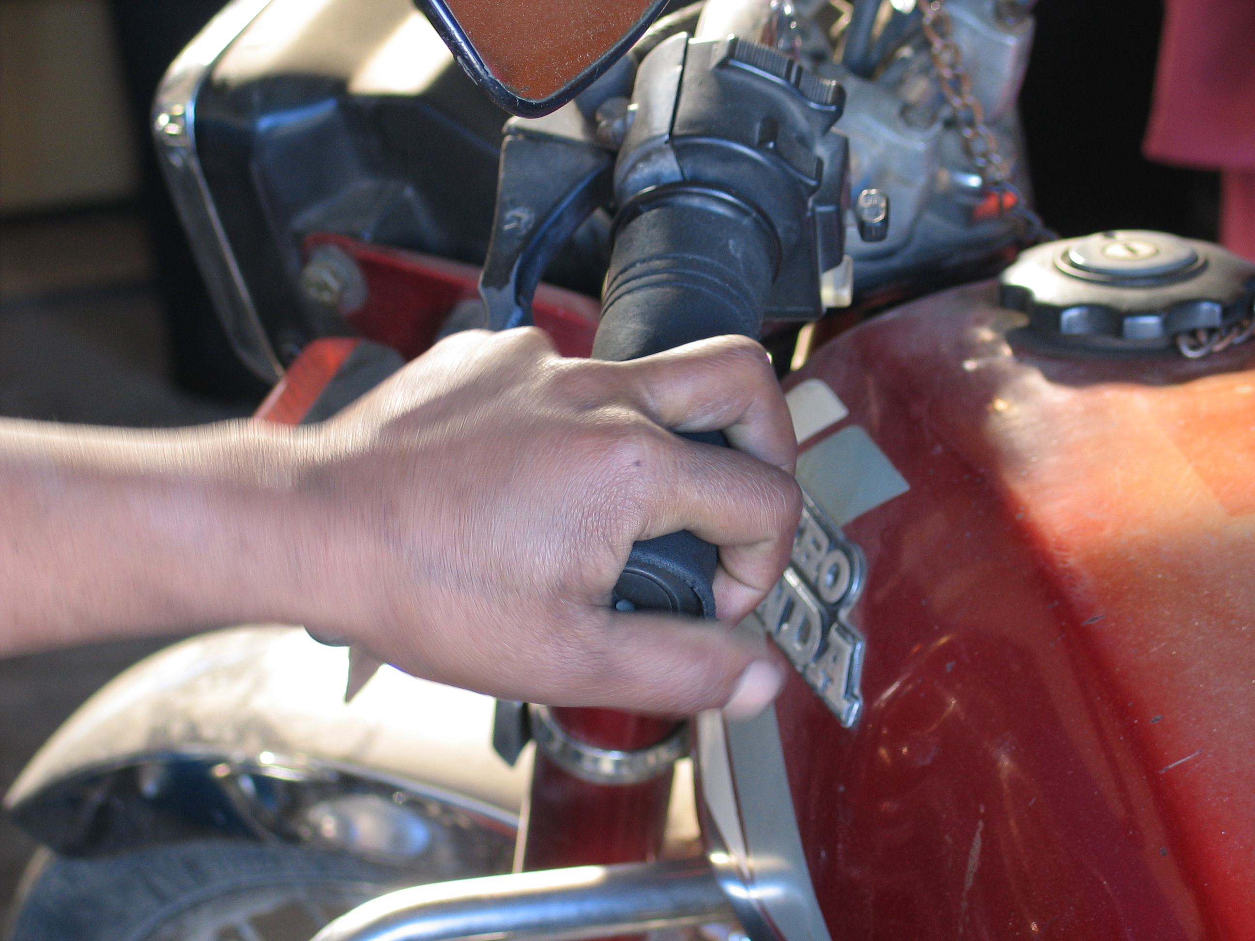
One of the first female motorcycle mechanics in Nepal.

The first electrical and electronics repair workshop was established in January 2008, next to the motorcycle shop in Sano Thimi, Bhaktapur. It is run by one woman. The second electrical workshop was established February 2008, and is located in Kirtipur, which is just on the outskirts of the main city center, and is run by two women.

The workshops are well-equipped with essential equipment and provide the women with a conducive work environment. Initially, the women were provided technical guidance on a daily basis by a supervisor, but after some months, UCEP needed only to provide refresher training to the women. UCEP also placed the women motorcycle mechanics on a rotating basis in already established and reputable motorcycle shops to enhance their knowledge and skills in repair, maintenance, and the management aspects of a workshop. In addition, all of the women were trained in basic bookkeeping, accounting, and inventory control. UCEP also introduced the young women to wholesale dealers so that they could purchase tools, spare parts, and equipment at reasonable and discounted prices in the future.

By the end of July 2008, NRF and UCEP helped the women to become officially registered owners of the workshops. In order to ensure the accountable and transparent use of the purchased equipment and the continued operation of the shops, NRF, UCEP, and TAF also signed a memorandum of understanding (MOU) with the women. The agreed terms and conditions outlined in the MOU stated that NRF and UCEP would continue to provide monitoring and guidance support to the beneficiaries, and that an inventory of all tools, spare parts, and equipment would be updated regularly and provided at the time of monitoring visits by NRF, UCEP and/or TAF. Further, in the case that the beneficiaries in any workshop/s decided not to continue the business, NRF and UCEP would have the authority to take over the shop/s and transfer them to a different female beneficiaries group. Finally, it was agreed that no shops could be shifted to another location without the prior notice and approval of NRF, UCEP and TAF, and that no tools and equipment could be sold or transferred without prior notice and approval of NRF and UCEP.

NRF and UCEP also initially helped the women shop owners by advertising the workshops in national newspapers and by placing banners in various locations to catch the target audience’s attention. They also conducted official launches of the workshops to gain media attention. To advertise the workshops, NRF and UCEP produced radio jingles and aired them for one month during January-February, 2008 on the popular Maitri FM “Traffic Hour” show. They also acquired two old and non-functional motorcycles, which they displayed outside the two motorcycle workshops to draw customers’ attention. The women also made business cards and created a 15% discount coupon to distribute to new patrons for future use, which has resulted in their retention of several regular customers. In recent months, because the workshops have been quite successful and the women are serving as positive role models to others of their background, UCEP plans to use the workshops for “on-the-job” training for all its female trainees.

Provision of additional equipment.
Building on the success of the four workshops, in October 2008, TAF was able get additional funding through the New Day Foundation for additional tools and equipment to the four existing workshops and the establishment of a third motorcycle workshop.

Since October, all of the workshops have been provided with additional equipment ranging from simple toolboxes, safety gloves and shoes, step ladders, wrenches, and pliers to larger equipment such as standing drills and a bike lifter with air compressor. At both the electric shops, additional provision of simple step-ladders has made it easier for the women to provide a fuller range of services during house calls. The project had budgeted for two motorbike lifters, but was only able to purchase one set (lifter and air compressor, pictured below) for the motorcycle shop in Sano Thimi, Bhaktapur. The other motorcycle shop owner in Imadol decided that she did not need a lifter, because the available lifters in Nepal would not fit in the workshop space and her work was running smoothly without it. The addition of the bike-lifter has made it much easier for the two girls in Sano Thimi to do their work, because they no longer have to bend down to get to hard-to-reach parts of a bike and can now work while standing up. Having a lifter has also helped to make their shop look more “professional” as customers see that they are a well-furnished repair shop. The women now have regular customers and have doubled their gross monthly income in the year since the shop was opened, from Rs. 8,000 to Rs. 18,000 (US $108.62 - $244.39) per month. Both women working in the Sano Thimi shop agreed that business has further improved in the last three months since receiving the motorbike lifter.

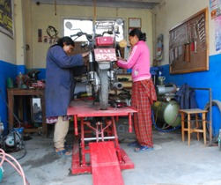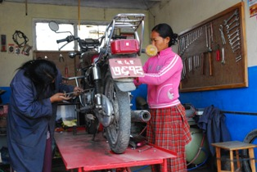
The motorbike lifter has made their job easier and helped to make the shop look more professional.

The greatest challenge facing all of the workshops is the serious power outages now affecting the Kathmandu Valley. The Kathmandu Valley now faces up to 20 hours of power outages a day, and this could increase even further in the coming months given the extreme shortages facing the country overall. Given this situation, the women at the motorcycle shops are not able to operate the facilities as fully as they would like, including such limitations as not being able to use the washing spray jets and having to wash bikes by hand. Similarly, even though the new lifter in the Sano Thimi shop has greatly improved working conditions, during times when there is no electricity the women have to resort to using manual tools; the manual foot pump has become one of the most indispensible pieces of equipment in all of the motorcycle shops. The power outages have also forced the women to be more entrepreneurial. The young woman at the Sano Thimi electric shop has started to make her own hand-made candles – an essential item during power outages – and is actually making a profit from this small side-business.

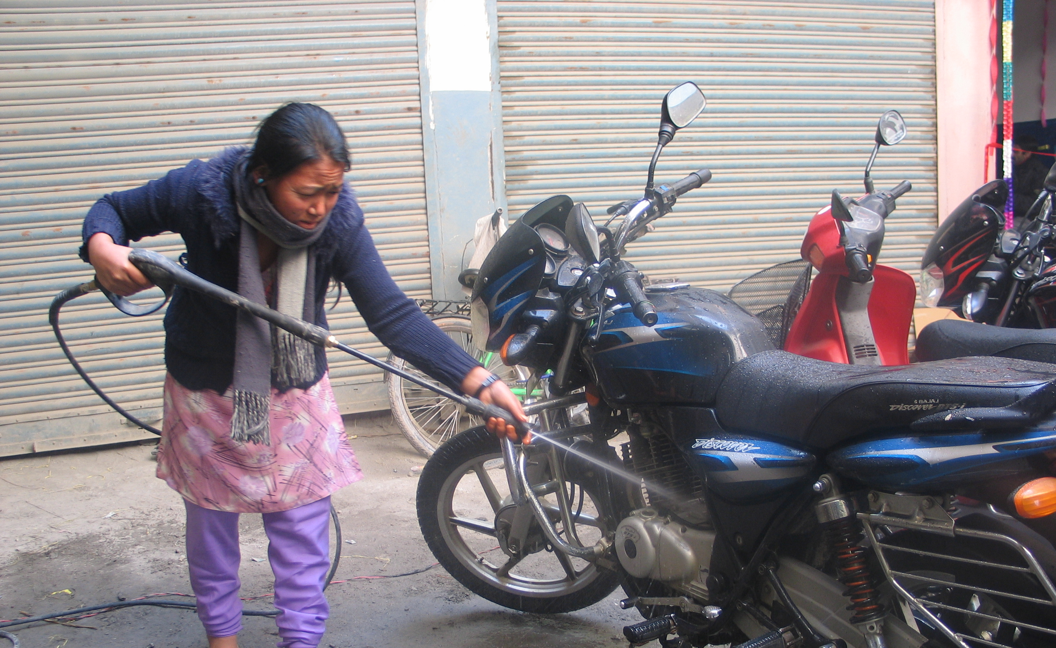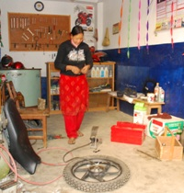
With electricity, they can use the washing spray jets. Without electricity, they turn to the most useful piece of equipment: the manual foot pump.

Establishment of the fifth workshop.

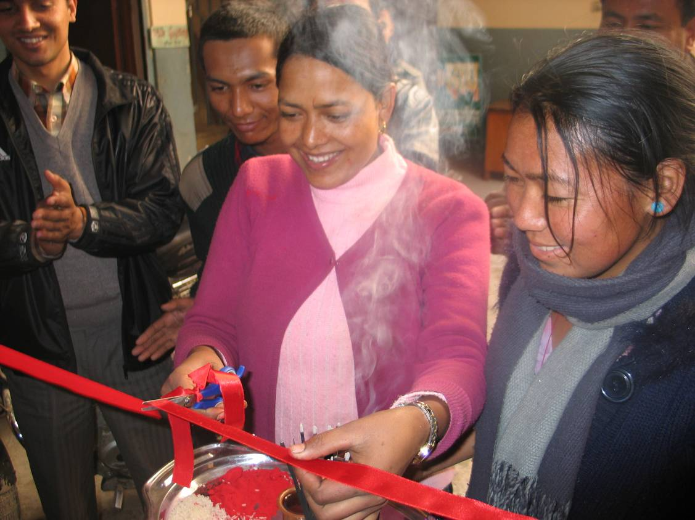
The opening ceremony of the fifth workshop.

In December 2008, a fifth workshop, a motorcycle repair shop, was established with funding received from the New Day Foundation. The shop is located off the busy ring road in Samakhusi, Kathmandu, and two women are currently working there. The shop was previously owned by a young man who decided to migrate to Qatar for work, and UCEP, in consultation with the beneficiaries, purchased the used equipment and refurbished the shop. The women are doing very well at this newest location after earning the trust and confidence of previous customers. Already, in the first three months since opening, they are earning a significant monthly income of Rs.18,000 to 20,000 (US $225.78 - $250.87).

THE WOMEN AND THEIR WORKSHOPS

Sano Thimi, Bhaktapur, motorcycle shop

The motorcycle shop in Sano Thimi, Bhaktapur sits on a busy road. The shop was originally run by Rina Darnal, Anita Bal, and Samjhana Thapa, but after some time Samjhana dropped out of the project due to family reasons. Anita and Rina continue to run this busy, thriving workshop. They both now have joint ownership of the shop, which has been operational for about 14 months.

Both Rina and Anita come from extremely poor families and both are clearly proud and happy about how much they have achieved since receiving the vocational training at UCEP. Twenty-year old Rina only has a fourth-grade education and previously worked on a farm in her village. She was recommended to UCEP for vocational training by Nepal Basobas Basti Samaraskhan Samiti (a squatter settlement committee). She now dreams of saving enough money to one day open her own shop in her village of Dharan in Sunsari district in eastern Nepal. Anita, who is from Sindhupalchowk district, was illiterate and also worked on a farm in her village. When she came to Kathmandu, she worked in one of the carpet factories in the city, and was recommended to UCEP by NRF. Both Rina and Anita selected this training after listening to presentations given by previous UCEP female graduates on their experience and successes working in this field. Fortuitously, one of the presenters was Khima Kumari B.K., who was to become the beneficiary of the fifth workshop.

After receiving the UCEP vocational training along with life skills and basic non-formal education, both women worked in local repair shops to gain more skills. Now, the young women are very enthusiastic about working in their own repair shop rather than under bosses who had sidelined them into doing only minor repair work, paid them poorly, and scolded them harshly for mistakes. The shop is registered with the local Auto Mechanics Trade Union, and the two women regularly attend union meetings. Often, they are the only women – along with the other female beneficiaries of this project – among the 100 or so attending members. When asked if they find this daunting, they say they feel proud. Moreover, the men, who initially were sometimes suspicious and doubtful, now encourage and congratulate them for being some of the first women motorcycle mechanics in the country.

Over the 14 months that the shop has been in operation, both Rina and Anita have gained more confidence in their ability and skills at motorcycle repair and maintenance. The shop is well-equipped with new tools provided by the New Day Foundation, and both women are clearly comfortable and knowledgeable about how to operate all the tools. The addition of the motorbike lifter has made their jobs much easier, and both agree that it has definitely benefited their business; people see the lifter and think that this is a “professional” shop, and they have been able to attract more customers. In the past six months alone, their business has grown from Rs. 8,000-9,000 (US $100.35-$112.89) per month (gross) to Rs. 16,000-18,000 (US $200.70 - $225.78). Once expenses are deducted, the women split the profits evenly between them.

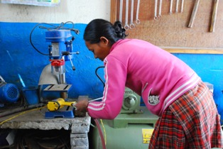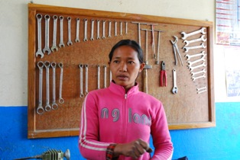
Using new tools purchased with the support of New Day Foundation.

Initially, it was hard for the two women to convince people that they knew what they were doing. Anita feels that male customers now have no problem having their bike fixed by the two women, because they trust the training they received from UCEP and have now seen their thorough and meticulous work first-hand. Both Rina and Anita said that some women customers and community members have definitely been inspired by them and have asked them how and where they learned the skills to repair bikes and how they managed to open their successful shop. Both the young, confident, and skilled women describe themselves as “ekdham khushi” – very happy.

Sano Thimi, Bhaktapur, electrical shop

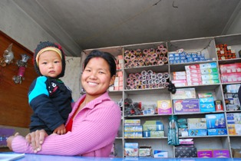

Next door to Anita and Rina’s motorcycle shop is Manita Gurung’s electrical shop. The shop was established about a year ago, and Manita is its sole proprietor. Twenty-five-year-old Manita is from Morang district in eastern Nepal. Like Anita and Rina, Manita also worked on a farm in her village before learning about the vocational training with UCEP. She opted for electronics and electrical training to try something new and different.

The small shop is stocked with all kinds of essential household electrical items such as extension cords, wires, and even energy-efficient light bulbs. When the shop first opened, Manita was only making about Rs. 700 per month (US $8.78). To save on rent, Manita lives right behind the shop with her young baby and her brother, who helps Manita run the shop. Manita’s husband has been working in Saudi Arabia for the past two years and sends what money he can to help support the family.

Manita also makes house calls about four to five times a month, and a recently purchased step ladder, provided by New Day Foundation, has greatly helped make her wiring jobs easier. When she is out making house calls, Manita is able to ask her brother or her friends next door to look after her young baby.

While Manita initially struggled to earn much of an income when she first started at the store, a year later she makes about Rs. 5,000-6,000 per month (US $62.72 - $75.26). In order to supplement her income from the electrical shop and her house calls, Manita has become quite entrepreneurial by taking advantage of the current 18-24 hour per day power outages in Kathmandu. Manita excitedly explained that she has started to make her own candles – an essential item during blackouts – and is selling them in her store, as an “electrical alternative” during times of need. She sells packets of the larger candles for Rs. 150 (US $1.88) and smaller ones for Rs. 45 (US $0.56). After paying for the wax and the rental of the candle molds, Manita is now making a nice profit of Rs. 2,000-3,000 per month (US $25.09 - $37.63) from her small side-business.

Manita would also like to move back to her village at some point to open her own shop there, but in the meantime she is planning to stay in Kathmandu and describes her life now as “ekdham fantastic!”—very fantastic!

Imadol, Kathmandu, motorcycle shop

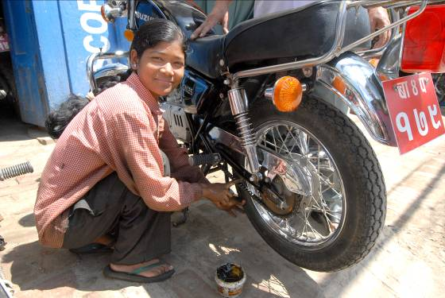
Twenty-year-old Saraswati Chaudhary is one of the proud owners of the motorcycle shop in Imadol, Lalitpur. She came from an extremely poor family, and once lived and worked in a squatter settlement built on a garbage dumpsite in the Kailali district of far western Nepal. As the eldest of five children, she was only able to study to Class 8 and then had to drop out at the age of 14 to work as a domestic servant, earning Rs. 60 (US $0.75) per day in order to help her family’s extremely poor economic condition.

She came into contact with The Asia Foundation’s Gainful Employment program through the district’s poverty reduction program, and selected motorcycle repair training because she believed that it would not be too difficult and wanted to get training in a non-traditional vocation. She worked at the Hero Honda (a popular brand) motorcycle repair workshop for a year before joining the Sanctuary Fund-supported Motorcycle Workshop. Saraswati said: “Customers doubt us when they see all women in this shop, but we need to prove ourselves with our work. I am not discouraged by people’s skepticism; I am just determined to do a good job and prove them wrong. It is great to have our own shop. We don’t have to work under bosses who scold us for the smallest mistake. We will make the most of this opportunity.” Her determination has definitely paid off and she now runs a thriving business. In addition, Asia Foundation and UCEP staff have started to use her as a peer mentor who can encourage other trainees to try non-traditional vocational training for future employment opportunities, given her success and confident personality.

When Sawaswati first finished her training and went home to meet her family, neither her family members nor her neighbors believed that she could repair motorcycles. Her father was so skeptical that he said “if you have learned about motorcycle repair, then prove it by driving this motorcycle.” To his surprise, Saraswati confidently hopped on the motorcycle and drove it around the village. Now, because of Saraswati’s help, her father, younger brother, and three younger sisters live nearby and have opened a small tea shop around the corner.

Saraswati and her husband, whom she met while at UCEP (he is also a graduate) run the shop. They earn about Rs. 18,000 per month (US $225.78). They used to earn about Rs. 28,000 (US $351.22), but because of the current power outage problems in Kathmandu, their earnings have declined. Still, Saraswati has loyal customers and there is an average of four to seven patrons a day; sometimes customers line up outside her shop as early at 6am, a full hour before opening time. Indeed, being the only one motorcycle shop in the area, and given her competence and friendly nature, her shop has become a local hangout in the neighborhood.

Kirtipur, Kathmandu, electrical shop

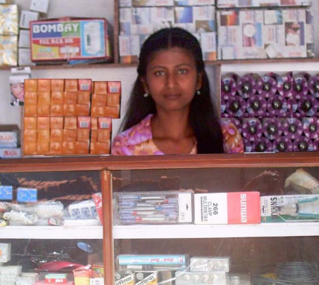
Twenty-one-year-old Ayesha Maharjan and Sajani Maharjan are the owners of the electrical repair shop in Kirtipur. Ayesha is from a poor family of six, and with her parents unable to work, she and her brother, who is a mason, are responsible for supporting the entire family. Sajani comes from a similar background, and the two girls knew each other before the training started. The road to success was not always clear for Ayesha. She first regretted opting for a non-traditional vocation instead of tailoring, knitting, or sewing like the other young women in the training program, because she thought it would be easier to earn money after the training. After establishing this shop, however, she is confident of her skills and ability to run a business. She considers herself to be extremely fortunate to have received such strong support from the Sanctuary Fund and expresses a need for additional training programs and business opportunities for young women so they can become economically empowered and respected in their families and communities.

While Ayesha and Sajani are friends, they have not very good business partners. Sajani subsequently decided not to continue working in the shop and now pursues sewing and knitting as a part-time job. In order to prevent the shop from closing down, UCEP plans to place one to two new female electrician trainees in this shop to assist Ayesha while gaining “on the job” training for their own development. If the two trainees are interested in joining the program after they complete their training, UCEP will continue to work with TAF to facilitate an appropriate placement for them.

Samakhusi, Kathmandu, motorcycle shop

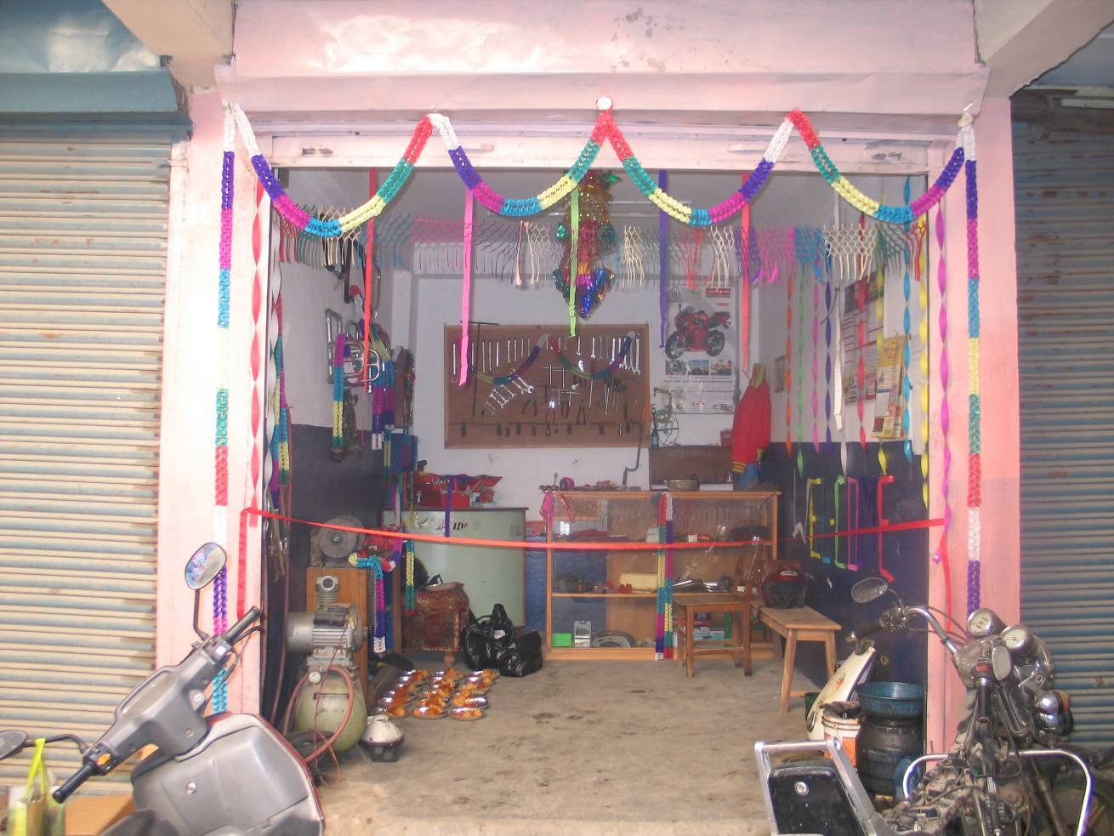

The motorcycle shop in Samakhuti is the newest of the workshops. It was established off of a busy main road and opened only three months ago with funding from the New Day Foundation. The rent for this shop is higher than that of the others—Rs. 5,000 instead of Rs. 1,500 (US $62.72 - $18.82)— but UCEP was able to keep other costs down by buying most of the equipment for the shop from its previous owner who left for employment abroad.

The bustling shop is run by Khima Kumari B.K., and will soon be fully registered in her name. Khima is a victim of the recent Maoist conflict in Nepal – both her father and brother were killed by Maoists. She is 22 years old and has a 10th grade education. She is from Bardiya district in mid-west Nepal. Khima was recommended for the UCEP vocational training by Rural Reconstruction Nepal (RRN), and her training was funded by Action Aid/Nepal. After receiving the six-month training from UCEP, Khima worked for the Annapurna Lifan motorcycle shop for two years and then had to return to her home in Bardiya for a year due to health problems. She then came back to Kathmandu and worked at the Yamaha workshop for about six months, earning only Rs. 1,200 (US $15.05). She was the only woman among six or seven men at the workshop.

In the three months that the shop has been open, business has grown tremendously and is now booming. Khima clearly enjoys her work and hardly has time to talk about her experience as she is always busy repairing a bike. Customers line up at her shop and she proudly says that business has gotten much better after they have seen her work. There is a lot of work and she has even had to hire a trainee worker to help her with the heavy workload. Since the shop opened, her gross income has grown from around Rs. 10,000 to almost Rs. 20,000 per month (US $124.44 - $250.88). Previously, she used to live with her mother and husband, but is now able to afford a place of her own after her husband went back to their home in Bardiya to work.

Like Anita and Rina, Khima also says that the current power outage situation in Kathmandu has hampered her ability to do certain things like washing or re-charging batteries – she says the manual foot pump is now her most important piece of equipment. But despite this real difficulty, Khima is positive and her business is thriving.

Khima says that she still needs to improve her technical skills and feels that she has not yet perfected her job. But she says that having responsibility for her own shop, instead of being given minor jobs at the larger workshops like Annapurna Lifan or Yamaha, has helped her to learn new skills quickly. She has grown more confident as a businesswoman and has recently bought supplies for the shop on credit; she is confident that she will be able to pay back her debt in no time. Khima is also a member of the Auto Mechanics Trade Union and serves as the representative for female mechanics. With this experience, Khima feels that she will be well-positioned and have earned enough money to go back to Bardiya with her husband, and open her own shop there one day.

On occasion, twenty-three-year-old Pema Sangmu Lama, who is from Mugu in far-western Nepal, helps Khima in the motorcycle shop. Pema is from one of the least-developed districts of Nepal – it takes a three-day walk, an hour’s flight, and an overnight bus journey for her to reach Kathmandu from her hometown. Pema comes from a very poor family. She used to work as a porter before she was forced to leave for Kathmandu to avoid being recruited by the Maoists. In Kathmandu, Pema joined her aunt who lived in a squatter settlement and worked in a carpet factory. Working in the factory was harsh; Pema received two meals a day with no salary. Within a year, however, she was discovered by NRF inspectors and brought into the Gainful Employment Program. Pema received six months of training in motorcycle repair and another six months of on-the-job training before she joined the Sanctuary Fund-supported Motorcycle Workshop. She originally worked with Saraswati in Imadol, but because her commute from home was extremely long, she was transferred to this new shop in Samakhusi.

Unlike Khima’s, Pema’s family has not been as supportive of her taking up a non-traditional job. In addition to the lack of familial support, Pema feels that even after being transferred to Samakhusi, the commute from her home in Bouddhanath to Samakhusi is still quite long, making it difficult for her to come to the shop regularly. In addition, her family is planning to go back to Mugu soon and Pema is trying to decide whether she will go back with them or remain alone in Kathmandu and continue to work as a mechanic. The Foundation is working with UCEP to try to provide her with various options to help her make her decision.

CHALLENGES AND LESSONS LEARNED

Perhaps one of the biggest challenges currently facing all the women participating in the project, and in fact all kinds of businesses in Kathmandu, is the lack of electricity. With the threat of increased hours of load-shedding from 18 to an occasional full 24 hours per day, all of the women are likely to experience a decline in income, something Saraswati has already witnessed. In this situation, it will be important for the women to improve their skills in working with manual tools. For the women working in the two electrical shops, the lack of electricity in the Kathmandu Valley is a major concern, and they will need to look at alternative ways to earn money, such as Manita’s candle-making side business, or selling back-up emergency lights.

Throughout the course of the project, TAF and its partners have learned several lessons that will help to strengthen similar projects in the future:

- Rapport-building with family and relatives is essential to the success of the repair shops. Family and friends of these young women were initially skeptical about their desire to participate in the project, and reluctant to support their working in non-traditional occupations. After consulting with some of the family members, however, the young women were able to prove their skills and increasingly gained family support to work in the repair shops. Unfortunately, in the case of one young woman from Jhapa district, her parents did not provide consent for her to work in Kathmandu, although she was keen on participating in the workshop. She was the sole initial beneficiary to have dropped out of the project.

- Supervisors for the workshops proved to be critically important for the women to gain knowledge and confidence in operating the shops. As skilled mechanics or repairmen, they assisted the young women in more complicated maintenance and repair problems. Finally, given the traditional perceptions of women in Nepal, the support of the male supervisors helped other community members to learn to trust the work of the young women.

- Refresher training offered the women more opportunities to improve their skills, and on-the-job training provided valuable experience in managing and operating a workshop. Exposure to other workshops helped the women to gain a greater understanding of business management and customer service and enabled them to return to their own shops with improved ideas for success.

- Practical considerations such as commuting time between work and home, as well as whether there is support for child care (e.g., in the case of Manita) also makes a difference in determining whether a young woman can be successful in running her own shop long-term.

RECOMMENDATIONS

Although it would be difficult to scale-up the “one-stop shop” model to reach every woman trained in non-traditional vocations, it is a model that can and should be replicated at relatively low cost. UCEP alone trains an average of 350 young men and women per year, and with additional funding the “one-stop shop” model could be replicated for its women graduates, not only in motorcycle repair and electronics but in other areas of training that UCEP provides (e.g., printmaking). In addition to setting up more shops, increased funding would also be useful in expanding and improving the existing shops so that they can provide employment for more young women (a women’s workshop or cooperative), and be used for more “on-the-job” training by UCEP or other vocational training schools in Nepal. The Asia Foundation is currently working on replicating this model with cohorts of young war widows in Nepal, a particularly vulnerable segment of society in a country that has experienced a decade-long civil war.

The workshops have not only helped the women who have participated directly in the project; by serving as venues for visits and on-the-job training by other UCEP trainees and graduates, the shops have provided women who are being trained in non-traditional vocations an opportunity to observe first-hand how disadvantaged women like themselves can ultimately succeed in running their own businesses. Indeed, they have served as an inspiration to other women who witness what women from even the most difficult backgrounds and low education levels can do if provided the right skills and opportunities.

The success of the “one-stop shop” model lies in the fact that it has truly empowered and improved the lives of the young women who have participated in the project. Not only are all the young women earning much more than they did previously; they have all gained a tremendous amount of knowledge, skills, confidence, and self-esteem through the process of running their own non-traditional business. The women entrepreneurs have not only been able to grow their businesses in Kathmandu, but with the knowledge they have acquired in running a business they will be able to open their own shops in their home districts if they wish, and thereby serve as positive role models for other young women in Nepal.

